**SQL : Structured Query Language**

DDL (Data Definition Language) – CREATE, DROP, ALTER

DML (Data Manipulation Language) – SELECT, INSERT, UPDATE, DELETE

DCL (Data Control Language) – GRANT, REVOKE

TCL (Transaction Control Language) – COMMIT, ROLLBACK

**SELECT**

SQL Functions: COUNT, MIN, MAX, AVG, SUM

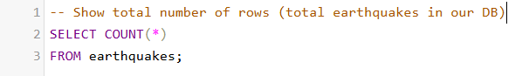

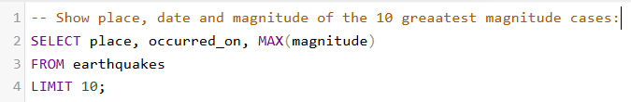

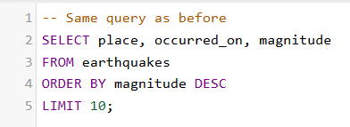

SELECT DISTINCT

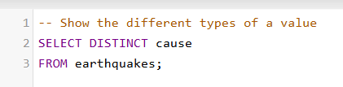

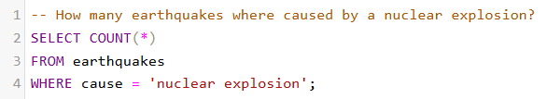

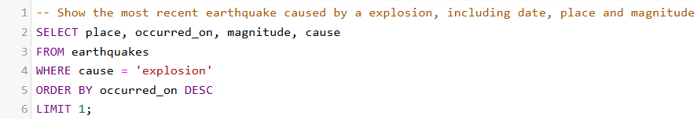

BETWEEN, LIKE

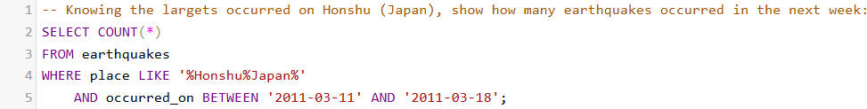

IN

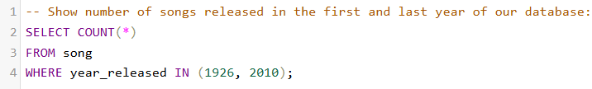

SUBQUERYS

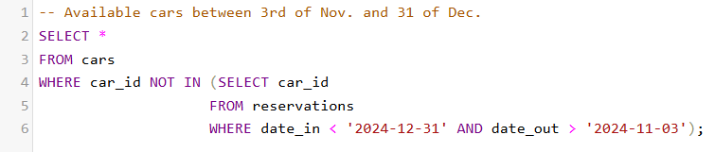

CONCAT / CONCAT_WS



**INSERT**

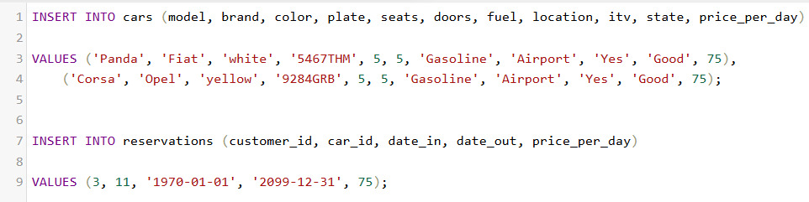

**UPDATE**

